Create authentication service that returns JWT
- As part of first step of JWT process, the user credentials needs to be sent to authentication service request that generates and returns the JWT.
- Ideally when the curl command is executed that calls the new authentication service, the token should be responded.
JwtApplication.java

SecurityConfig.java


AuthenticationController.java

JwtService.java


Output:
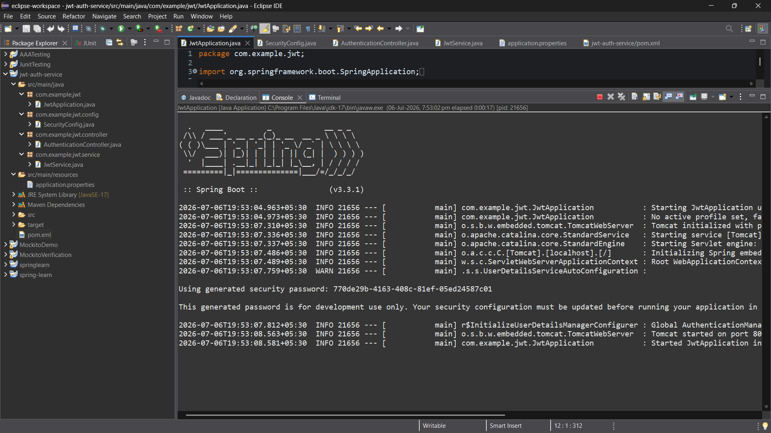
Request
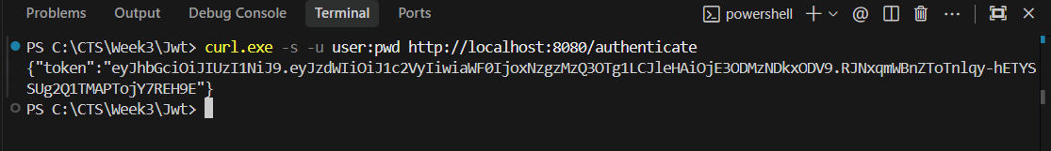
Response
